Analysis of Modern Sensor Technologies

Abstract— This report provides an in-depth technical analysis of fundamental and advanced sensor technologies used in modern electronics, robotics, and industrial automation. The paper examines the working principles, structural diagrams, and applications of proximity sensors, Inertial Measurement Units (IMUs), encoders, Hall Effect sensors, and Light Dependent Resistors (LDRs). Furthermore, two additional sensors (LiDAR and Ultrasonic Sensors) are explored. Understanding the physical mechanisms and data output of these components is critical for designing robust embedded systems.
Keywords— Sensors, IMU, Proximity Detection, Hall Effect, Encoders, LDR, LiDAR, Automation.

Introduction (Heading 1)
Sensors act as the fundamental bridge between the physical world and digital embedded systems. They convert various physical phenomena such as motion, light, magnetic fields, and spatial positioning into measurable electrical signals. The selection of an appropriate sensor dictates the accuracy, responsiveness, and overall viability of any mechatronic or IoT system. This report systematically breaks down essential sensor classifications to provide a working knowledge of their internal mechanics and real-world implementations in Industry environments.

Proximity sensors

Inductive Proximity Sensors
Inductive sensors rely on electromagnetic induction and are strictly used to detect metallic objects. An oscillator drives a coil, generating a high-frequency electromagnetic field at the sensor's face. When a metal target enters this field, eddy currents are induced in the target, drawing energy away from the oscillator. This amplitude drop triggers a Schmitt trigger circuit, switching the sensor's output state. They are heavily utilized in harsh industrial environments for gear tooth detection and limit switching due to their immunity to dust and oil.
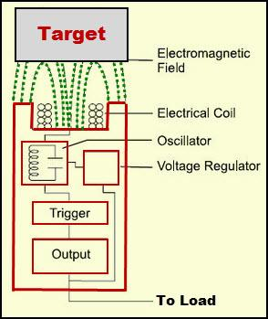
Fig. 1. Functional block diagram and electromagnetic detection principle of an inductive proximity sensor.

Capacitive Proximity Sensors
Unlike inductive sensors, capacitive sensors can detect both metallic and non-metallic objects, including liquids, plastics, and wood. The sensor's sensing surface forms one plate of a capacitor, and the target acts as the other plate. As the object approaches, the dielectric constant changes, increasing the capacitance and changing the amplitude of the internal oscillator, which triggers the output.

Optical/Photoelectric Proximity Sensors
These sensors use a light source (usually infrared LED) and a photoelectric receiver. They operate in three main modes:
- Through-beam: Emitter and receiver are placed opposite each other. The target breaks the beam.
- Retro-reflective: The emitter and receiver k are in one housing; a reflector bounces the light back.
- Diffuse: The emitter and receiver are in one housing. The target itself reflects the light back to the receiver.

Inertial Measurement Unit (IMU)
An IMU is a highly complex electronic module that measures a body's specific force, angular rate, and sometimes the magnetic field surrounding the body. A standard 6-DOF (Degrees of Freedom) IMU contains a 3-axis accelerometer and a 3-axis gyroscope whereas a 9-DOF unit integrates an additional tri-axial magnetometer.
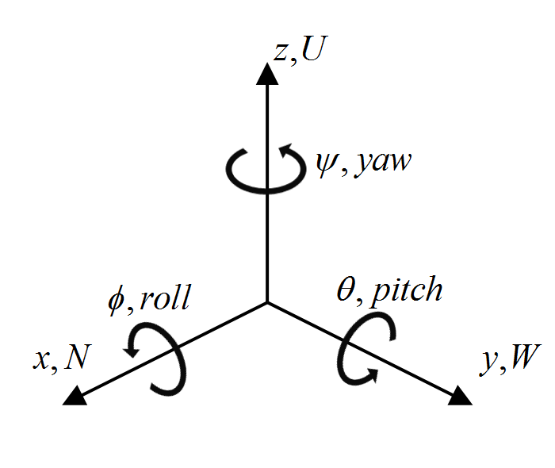
Fig. 2. Coordinate axis orientation and angular rate (roll, pitch, yaw) definition in a 6-DOF IMU.
- Accelerometer: Measures linear acceleration using MEMS (Micro-Electromechanical Systems) technology. Inside the chip, microscopic proof masses are suspended by silicon springs. Acceleration causes the mass to deflect, changing the capacitance between the mass and fixed plates, generating a voltage proportional to the acceleration.
- Gyroscope: Measures angular velocity (rotation) based on the Coriolis effect. As a resonating mass undergoes rotation, a secondary orthogonal vibration is induced, which is capacitively measured to determine Pitch, Roll, and Yaw.
- Magnetometer: Measures the Earth's magnetic field via the Hall effect or magneto-resistive elements, acting as a digital compass to correct gyroscope drift over time.

Encoders
Encoders are electromechanical devices that convert the angular position or motion of a shaft into analog or digital output signals. They are vital for precise motor control and CNC machinery.
Optical encoders are the most common due to their high resolution. A light source (LED) shines through a rotating code wheel (disc) patterned with opaque and transparent slots. A photo-detector on the other side registers the light pulses. By analyzing the phase shift between two output channels (Channel A and Channel B, known as quadrature output), the microcontroller can determine both the speed and the direction of rotation.
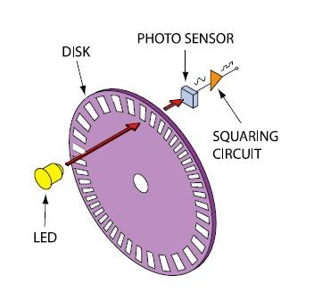
Fig. 3. Optical rotary encoder disc layout and 2-channel quadrature square-wave output.

Hall Effect Sensors
A Hall Effect sensor is a transducer that varies its output voltage in response to a magnetic field. It is named after Edwin Hall, who discovered the principle in 1879.
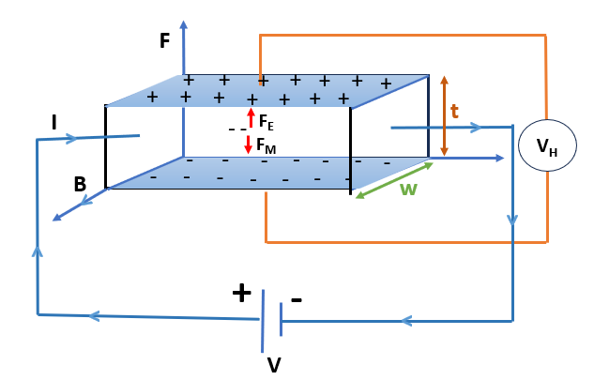
Fig. 4. Deflection of charge carriers by the Lorentz force generating transverse Hall voltage.
Working Principle: When a current-carrying conductor (or semiconductor) is placed in a perpendicular magnetic field, the Lorentz force acts on the charge carriers (electrons or holes), deflecting them to one side of the material. This separation of charge creates a measurable potential difference across the conductor, known as the Hall Voltage. The voltage is directly proportional to the magnetic field strength.

Light Dependent Resistor
An LDR, or photoresistor, is a passive component that decreases resistance with respect to receiving luminosity (light) on the component's sensitive surface.
Working Principle: LDRs are constructed from high-resistance semiconductor materials, typically Cadmium Sulfide (CdS). When photons of light strike the semiconductor with energy greater than the bandgap of the material, electrons are excited from the valence band to the conduction band. This massive increase in free charge carriers drastically lowers the electrical resistance of the component. They are commonly configured in a voltage divider circuit for automated lighting controls.

VII. Additional Sensor Technologies
To broaden the scope of this analysis, two additional sensor types utilized in modern systems are detailed below:
A. LiDAR (Light Detection and Ranging)
LiDAR is a time-of-flight (ToF) remote sensing method used to map 3D spaces. It emits rapidly pulsing laser beams and measures the exact time it takes for the light to bounce back from an obstacle. By calculating time against the speed of light, precise distance point-clouds are generated. LiDAR is the primary vision system for autonomous vehicle navigation.

B. Ultrasonic Distance Sensors
Similar in concept to LiDAR, ultrasonic sensors use sound waves instead of light. The sensor emits a high-frequency ultrasonic pulse (typically 40 kHz) and waits for the echo. Distance is calculated using the speed of sound in air. They provide highly effective and inexpensive collision avoidance in robotics.

- SENSOR COMPARISON
Sensor Type | Primary Application | Key Physical Principle
Inductive Proximity | Metal object detection in industrial automation | Electromagnetic induction & Eddy currents
IMU (Inertial Measurement Unit) | Spatial tracking, drone navigation, VR | Coriolis effect (Gyroscope) & Proof-mass capacitance (Accelerometer)
Optical Encoders | Motor speed and shaft position tracking | Photoelectric pulses & Quadrature phase shift
Hall Effect Sensors | RPM calculation, BLDC motor commutation | Lorentz force deflecting charge carriers in a magnetic field
LiDAR | Autonomous vehicles, Topographical mapping | Time-of-Flight (ToF) using pulsed laser light

IX. Conclusion
The accurate acquisition of environmental data relies entirely on the correct implementation of sensor technologies. From the electromagnetic principles governing Hall Effect sensors to the photoelectric mechanisms of encoders, each sensor offers unique advantages for distinct engineering challenges. A deep understanding of these devices is essential for developing reliable and responsive automated systems.

References
[1] M. Javaid, A. Haleem, R. Singh, S. Rab, and R. Suman, "Significance of sensors for industry 4.0: Roles, capabilities, and applications," Sensors International, vol. 2, p. 100110, 2021.
[2] M. Mingsheng, Y. Wang, F. Liu, F. Zhang, Z. Liu, and Y. Li, "Passive wireless lc proximity sensor based on ltcc technology," Sensors, vol. 19, no. 5, p. 1110, 2019.
[3] M. Kok, J. D. Hol, and T. B. Schön, "Using inertial sensors for position and orientation estimation," Foundations and Trends® in Signal Processing, vol. 11, no. 1-2, pp. 1–153, 2017.
[4] R. Akkaya and F. A. Kazan, "A new method for angular speed measurement with absolute encoder," Elektronika ir Elektrotechnika, vol. 26, no. 1, pp. 42–47, 2020.
[5] C. Walsh, M. Sadeghi, and M. Missous, "Physical modelling of InGaAs/AlGaAs/GaAs 2DEG structures for integrated Hall effect circuits," in 2026 IEEE International Magnetic Conference (INTERMAG Short Papers), pp. 1–2, 2026.
[6] N. Z. Simon, B. Ambrosio, and N. Hermosa, "A simple calibration experiment for light dependent resistors using Malus law," European Journal of Physics, vol. 44, no. 5, p. 055702, 2023.
[7] T. Staffas, A. Elshaari, and V. Zwiller, "Frequency modulated continuous wave and time of flight LIDAR with single photons: A comparison," Optics Express, vol. 32, no. 5, pp. 7332–7341, 2024.
[8] Y. Vázquez-Gutiérrez, D. O'Sullivan, and R. Kavanagh, "Small-signal modeling of the incremental optical encoder for motor control," IEEE Transactions on Industrial Electronics, vol. 67, no. 5, pp. 3452–3461, 2020.

